**PROJECT TOPIC: RESUME ANALYZER**

**Specialization: CSE**

**Project Group Members:**

1. Kaustubh Dubey(B- 29/201500332)
2. Shreyash Varshney(F-58/201500675)

**Project Mentor:** Dr. Mayank Srivastava, Assistant Professor

**Objective:** A resume analyzer aims to efficiently evaluate resumes, aligning candidates' qualifications with job requirements. It streamlines the screening process for recruiters, ensuring accuracy and relevance in candidate selection. Additionally, it provides constructive feedback to applicants for enhancing their resumes and maximizing their chances of success.

**Tools required:**

* **Hardware Requirements:**
* Intel Core i5 or i7, AMD Ryzen 5 or 7 and at least 8 GB of RAM.
* SSD (Solid State Drive)
* Internet Connectivity
* Peripherals: Mouse, keyboard, Monitor
* **Software Requirements:**
* Python 2.7 (& libraries)
* Anaconda Distribution
* Web Browser

**Abstract:** Resume analysis plays a crucial role in the recruitment process, serving as the initial filter for identifying potential candidates. In this context, a resume analyzer is developed to automate and streamline the process of resume screening. This system leverages natural language processing (NLP) techniques and machine learning algorithms to extract relevant information from resumes, such as qualifications, skills, and experiences. By comparing this extracted data with job requirements, the analyzer identifies suitable candidates and provides insights to recruiters or job seekers. Additionally, the analyzer offers feedback on resume quality, aiding candidates in improving their presentation and increasing their chances of success. Through its efficient and objective evaluation of resumes, the analyzer contributes to enhancing the efficiency and effectiveness of the recruitment process, benefiting both employers and job seekers alike.

**Outcome:**

**STARTING WINDOW OF RESUME ANALYZER**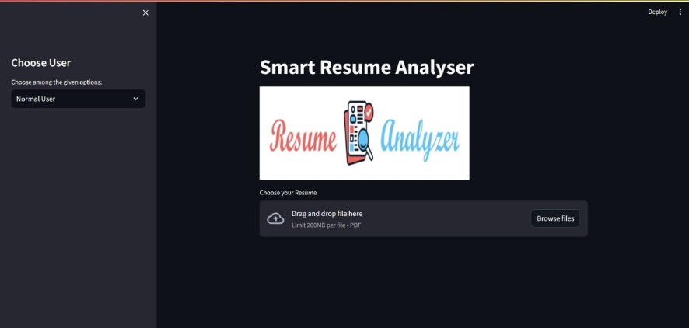

**ADMIN SIDE STARTING WINDOW**

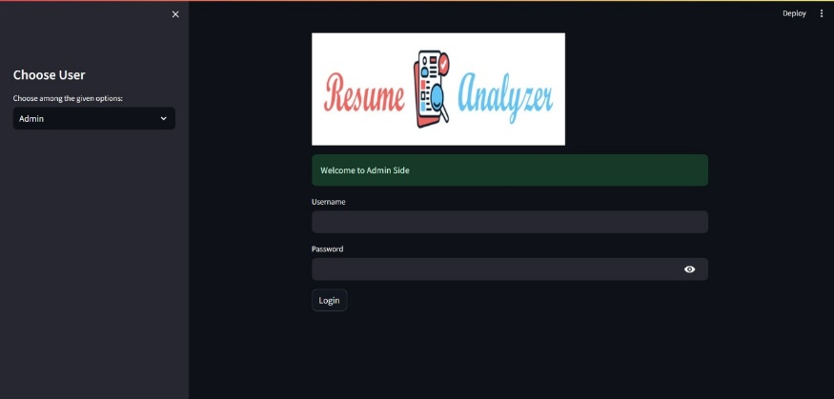

**UPLOADING RSUME**

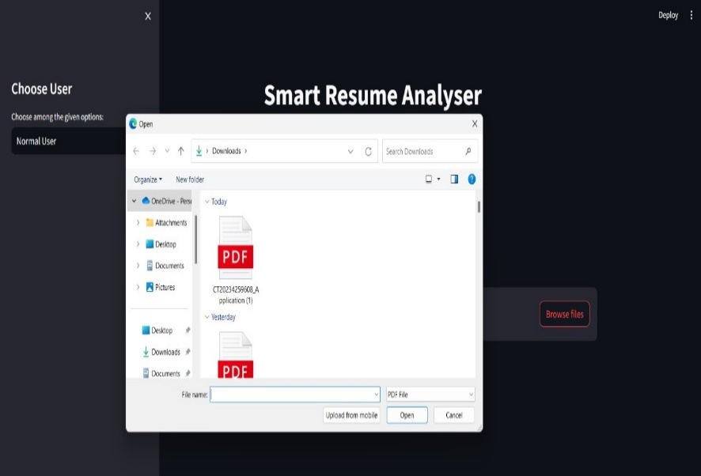

**EXTRACTING KEYWORDS**

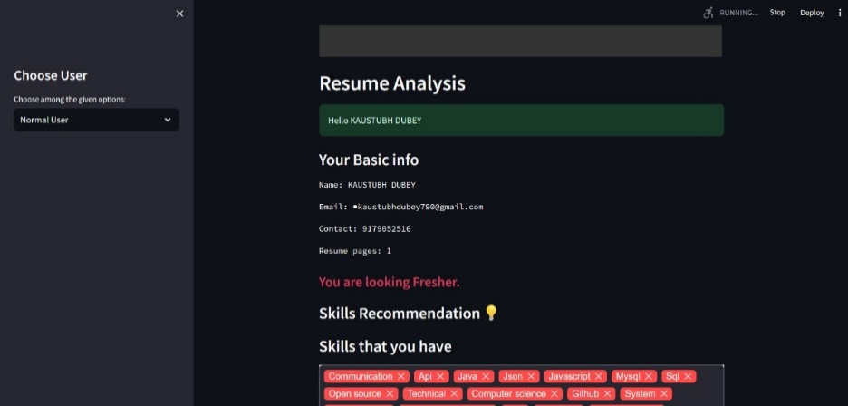

**CHOOSE USER**

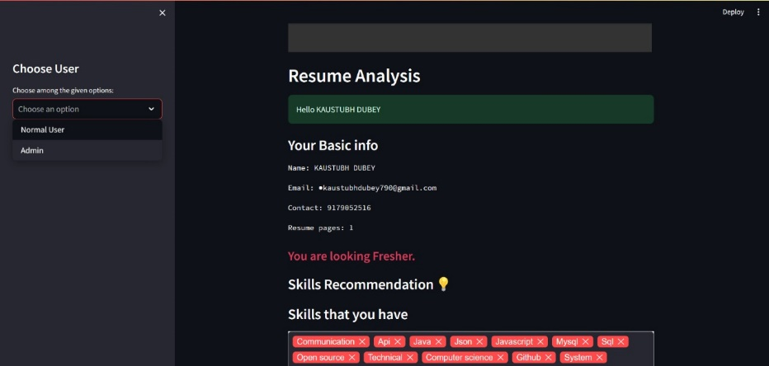

**SHOWING INFO. OF USER DATA**

